|  |  |  |
| --- | --- | --- |
|  | BCD TO ASCII CONVERSION USING 8051 |  |
| Exp No.: 14 |  | **Name:** S Vishakan |
| Date: 21-10-2020 |  | **Reg. No:** 18 5001 196 |

**AIM:**

To write an assembly language program to convert a given BCD value to its corresponding ASCII value using an 8051 microcontroller.

**PROGRAM – 1: BCD TO ASCII CONVERSION:**

**ALGORITHM:**

1. Begin.
2. Move the value in R1 to A.
3. Get the lower byte at A by performing logical AND over A & 0F.
4. Add 30h to A.
5. Move A to R4.
6. Move the value in R1 to A.
7. Get the higher byte at A by performing logical AND over A & F0.
8. Swap the lower and higher nibble in A.
9. Add 30h to A.
10. Move A to R3.
11. End.

|  |  |
| --- | --- |
| **PROGRAM** | **COMMENTS** |
| MOV R0, #00 | R0 has address of 0x00 |
| MOV A, R1 | Moving BCD value to A |
| ANL A, #0FH | Taking lower byte value of A by doing (byte & 0F) |
| ADD A, #30H | Add 30H to lower byte to convert it to ASCII |
| MOV R4, A | Move lower ASCII byte to R4 from A |
|  |  |
| MOV A, R1 | Moving BCD value again to A |
| ANL A, #0F0H | Taking higher byte value of A by doing (byte & F0) |
| SWAP A | Swap the lower and higher bytes in A |
| ADD A, #30H | Add 30H to higher byte to convert it to ASCII |
| MOV R3, A | Move higher ASCII byte to R3 from A |
|  |  |
| HALT: |  |
| SJMP HALT | Halt the program with a loop. |

**SAMPLE I/O SNAPSHOT:**

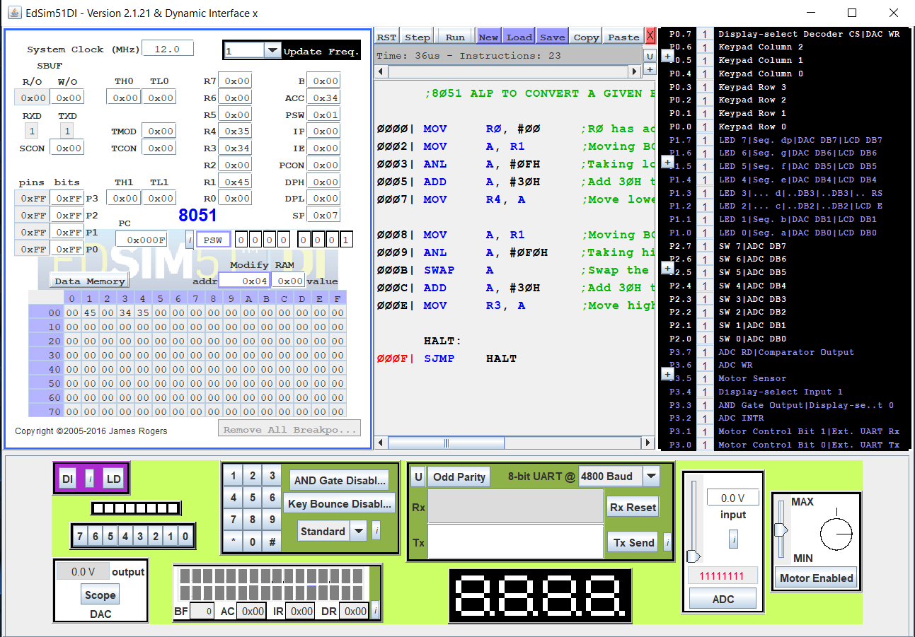

**RESULT:**

An assembly level program was written to convert a given BCD value to its corresponding ASCII value using an 8051 microcontroller and the output was verified.